Machine Learning Approach for forest fire prediction

Authors:
ARUNKUMAR V KANIMOZHI.V
oyeahitsarun@gmail.com kanimozhi.v@inurture.co.in
Abstract:
The widespread use of machine learning has impacted various aspects of human life, such as online recommendations, self-driving cars, and machine translation. One major issue in today's world is the devastating effects of climate change, particularly forest fires. These fires lead to loss of life, soil erosion, and destruction of vegetation. In recent years, the frequency of forest fires has risen and the affected area has grown. On average, 70,072 fires occur annually, destroying 7 million acres of land. Early detection of these fires is crucial in order to minimize their impact on the environment; however, the primary cause of these fires is human activities and the decrease in forest cover. The goal of early fire detection is to reduce the harm caused by these fires.

Introduction:
Forest fires pose a serious threat to the ecosystem and its inhabitants. Natural causes such as high temperatures and low humidity, as well as human activities, can lead to devastating forest fires, like the one in Tamil Nadu, India in 2018 that claimed many lives. Canada is known for its advanced forest fire prediction system which uses the Forest Weather Index (FWI) to assess the risk of fire by considering various environmental factors such as atmospheric conditions, material dryness, presence of flammable materials, and ignition sources other factors include rainfall patterns, flooding, and human negligence. Deforestation caused by fires can have severe consequences for humanity. Early detection is crucial in effectively responding to and controlling fires, with forest fire centres able to respond within 6 minutes of a fire starting to prevent lasting damage to the forest[ ] , Forest fire prediction involves taking into account various environmental factors such as atmospheric conditions, the dryness of fire-resistant materials, the presence of flammable materials, and ignition sources, to assess the risk of fire and predict the likelihood of combustion in Forest fire prediction involves taking into account various environmental factors such as atmospheric conditions, the dryness of fire-resistant materials, the presence of flammable materials, and ignition sources, to assess the risk of fire and predict the likelihood of combustion in forests.[] Extreme temperatures, moderate humidity, high wind speeds, significantly raise the chance of burning. It is also found that the number of fires in forests is higher than in other surface areas. [] By Using the Forest Weather index, Machine learning model in a user interface can be very effective to not at all Forest officers also.

Canadian Forest Fire Watch: A Comprehensive Predictive System
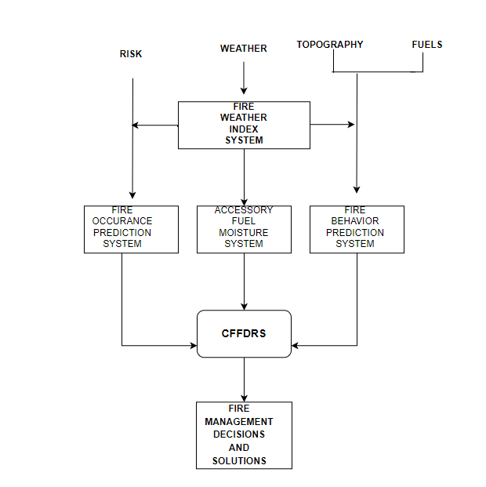
The methods and procedures the Canadian government and associated agencies employ to identify, stop, and deal with forest fires across the nation are referred to as the Canadian forest fire system. This covers the application of satellite technology, ground-based surveillance, and firefighting tools and manpower. The Canadian Forest fire system's objective is to safeguard the safe and efficient use of fire as a normal ecological process while simultaneously safeguarding communities, forests, and animals from the harmful effects of forest fires.

CFFDRS Architecture(i)

Fire Weather Index System:
The Canadian Forest Fire Weather Index (FWI) System is a system that evaluates the potential for forest fires based on six factors. These six factors consist of three fuel moisture codes and three fire behaviour indices. The fuel moisture codes indicate the dryness of the forest floor and other dead organic matter, with higher values indicating lower moisture content. The fire behaviour indices measure the speed of fire spread, the amount of fuel available for burning, and the intensity of the fire at the front, with higher values indicating higher fire danger. 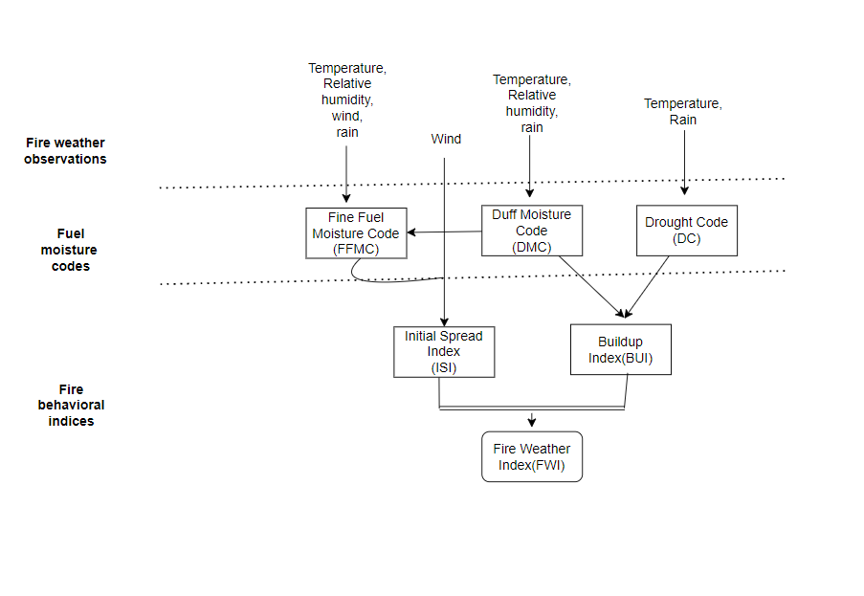
FWI Architecture(ii)
On fire weather observations, observations are taken like Temperature, Relative humidity, Wind and Rain these four observations very important reason for climate and disasters. These observations are fed into mathematical calculations, On the fuel moisture codes FFMC, DMC, DC were calculated
- FFMC represents fuel moisture of forest litter fuels under the shade of a forest canopy. It is intended to represent moisture conditions for shaded litter fuels, the equivalent of 16-hour time lag. It ranges from 0-101. Subtracting the FFMC value from 100 can provide an estimate for the equivalent (approximately 10h) fuel moisture content, most accurate when FFMC values are roughly above 80.
- The Duff Moisture Code (DMC) represents fuel moisture of decomposed organic material underneath the litter. System designers suggest that it is represents moisture conditions for the equivalent of 15-day (or 360 hr) time lag fuels. It is unitless and open ended. It may provide insight to live fuel moisture stress.
- The Drought Code (DC), much like the Keetch-Byrum Drought Index, represents drying deep into the soil. It approximates moisture conditions for the equivalent of 53-day (1272 hour) time lag fuels. It is unitless, with a maximum value of 1000. Extreme drought conditions have produced DC values near 800.

On fire behavioural indices ISI, BUI and FWI is calculated:
- The Initial Spread Index (ISI) is analogous to the NFDRS Spread Component (SC). It integrates fuel moisture for fine dead fuels and surface windspeed to estimate a spread potential. ISI is a key input for fire behaviour predictions in the FBP system. It is unitless and open ended.
- The Build-up Index (BUI) is analogous to the NFDRS Energy Release Component (ERC). It combines the current DMC and DC to produce an estimate of potential heat release in heavier fuels. It is unitless and open ended. In Alaska and the Lake States, it is the primary indicator of season severity during the growing season.
- The Fire Weather Index (FWI) integrates current ISI and BUI to produce a unitless index of general fire intensity potential. It is analogous to NFDRS Burning Index. With dry fuel conditions, it is a key indicator of extreme fire behaviour potential. Again, unitless and open ended.
Simply ISI is the spread of fire and BUI is fuel flammability.

Existing System:
The Existing system utilizes meteorological factors such as temperature, rain, wind, and humidity to forecast the likelihood of forest fires. The system employs the RandomizedSearchCV technique and the Random Forest Regression model to improve prediction accuracy and reduce overfitting. By fitting numerous decision trees to different subsets of data and averaging the results, the system produces a more accurate analysis of the relationship between meteorological parameters and forest fires. The study compares multiple models, including Decision Trees, Random Forests, Support Vector Machines, and Artificial Neural Networks, to determine the best approach for forest fire prediction.
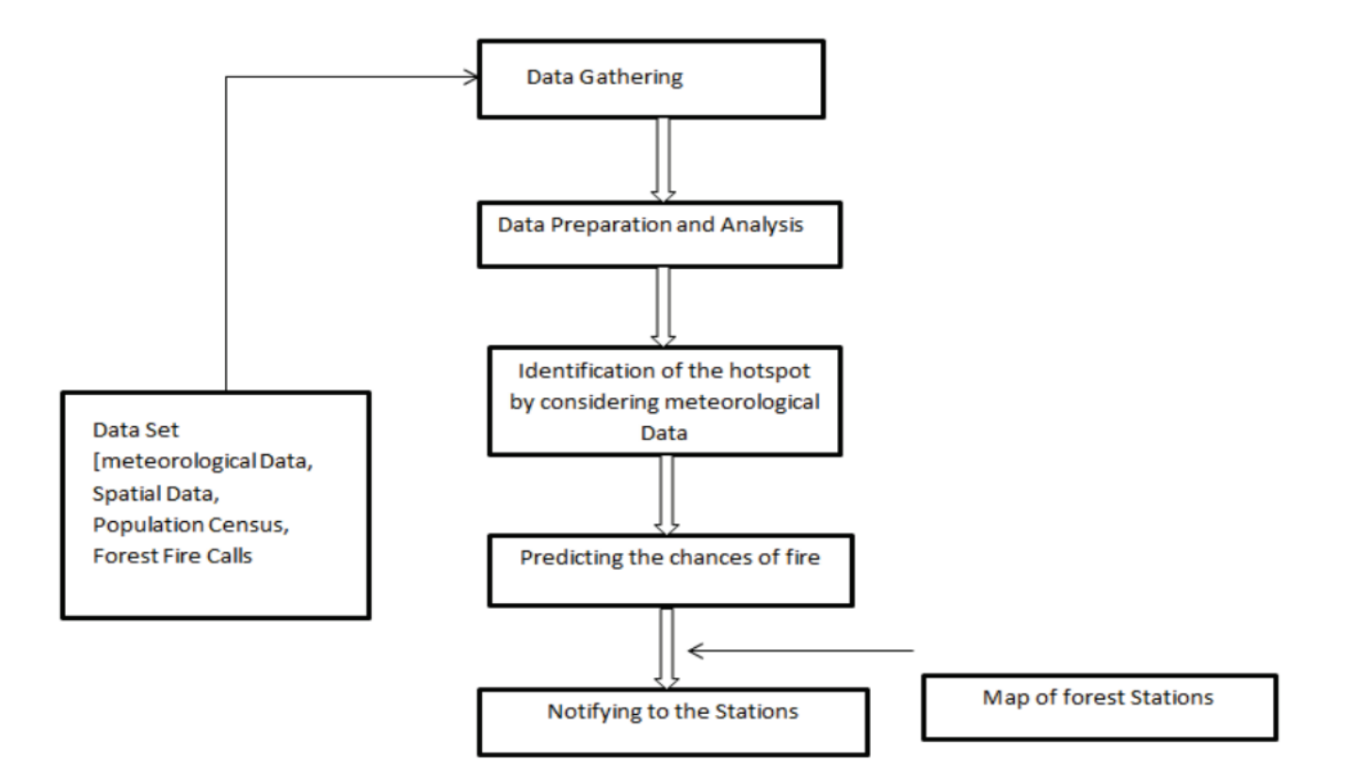
Existing System(iii)
Pre-processing where they remove the noisy data and converting that categorical data to numerical data so it will be easy to understand that dataset. After the pre-processing technique and then hotspot location is identified based on the meteorological data available in the data set then apply the models to predict the chances of occurrence of fire and send the notification to the nearest station. Following the division of the data into training and test sets, do pre-processing and feature extraction on the training data before storing it in a database. extract data for testing from the database, test it, do a quantitative analysis, and display the results as a fire forecast

Proposed system:
Collected data which includes sets of data with null values and outliers, first. After removing the outliers, run statistical analysis on the data-set to discover any attributes that are correlated. After applying the algorithm to the data-set, grid search-CV is used to tune the hyper parameters. then discovered a fantastic hyper parameter that performs incredibly accurately. The same procedure is carried out for each algorithm after which it is compared with high accuracy to all other algorithms
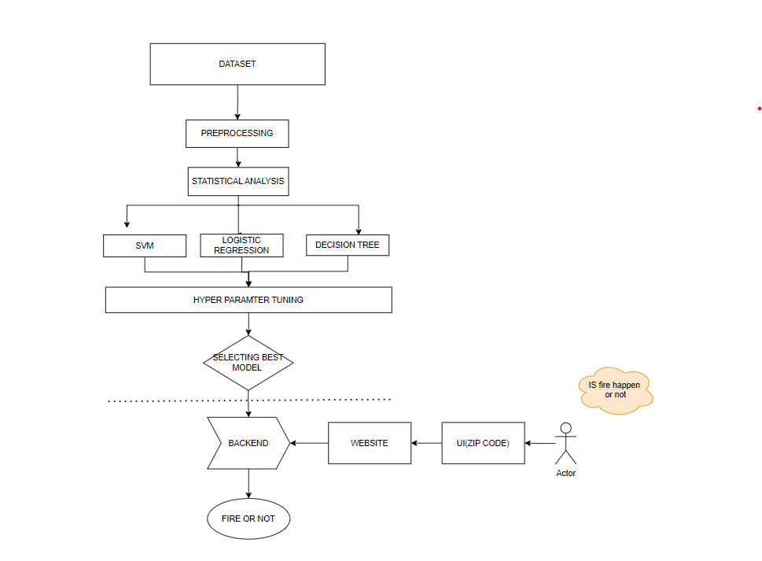
Block Diagram of Proposed Model(iv)
The Algerian Forest fire Dataset is used here, on pre-processing techniques all the outliers and null values are removed. On feature classes the fire and non-fire is transformed into 0 and 1.
Then Statistical analysis is done with the dataset then the data is fed into models for model selection, the models are more likely to be classification model logistic regression
and Decision tree .From the above Models I have selected the best performing model and the performance is tuned by hyperparameter, For hyperparameter tuning gridsearch cv used.
For Logistic regression the best performing parameters are: {'C': 2, 'max_iter': 100, 'penalty': 'l2'}, then for support vector machine {'C': 0.001, 'gamma': 1, 'kernel': 'linear'}, and for Decision tree the best performing hyper parameter {'criterion': 'Gini', 'max_depth': 1}

Then the accuracies are compared to select the model to use for complete model and for deployment
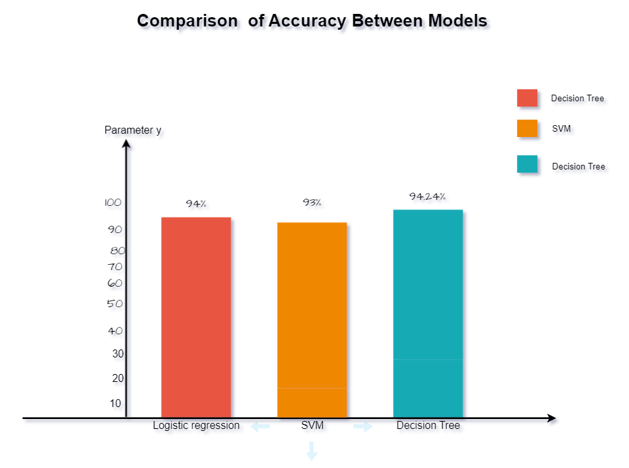
From the above graph we know that decision tree gives the best accuracy of 94.46 percentage, so now the decision tree is selected and then for further improvement of accuracy of decision tree ensemble model random forest is used. Then now the accuracy of the model got increased to 95.56% this model is selected for deployment. Then it deployed with lot of calculations like FFMC, DMC, DC, BUI, FWI are calculated within the website then it is given as input to
The ML models.

Algorithms:
Logistic regression: Logistic Regression is a statistical method used for binary classification problems, where the outcome is either 0 or 1. It is used to model a relationship between independent variables and a dependent binary variable by fitting a logistic curve. The logistic curve is a sigmoid function that maps the input variables to a probability between 0 and 1. The probability can be used to make predictions about the dependent binary variable.
The logistic curve will predict which type the input the input will be.
p(y=1|x) = 1 / (1 + exp(-z)) where z is the linear combination of input features x and weights w:
z = w_0 + w_1x_1 + w_2x_2 + ... + w_nx_n,
The output p(y=1|x) is the predicted probability that the target variable y is equal to 1, given the input features x.
Support Vector machine:
It works by finding the best hyperplane that separates the data points into classes. In the case binary classification, the SVM algorithm seeks to find the hyperplane that maximizes the margin between the two classes. The margin is defined as the distance between the hyperplane and the closest data points, called support vectors, that define the boundary.
The hyperplane is represented by a weight vector, w, and a bias term, b. The equation for a hyperplane can be written as:
w^T x + b = 0

Decision Tree:
A Decision Tree is a tree-based model used for classification and regression problems in
machine learning. The tree consists of internal nodes, which represent decisions or tests on the input features, and leaf nodes, which represent the prediction or class label for a particular
set of input values. The process of building a decision tree starts with selecting the best feature to split the data at the root node. The criterion for selecting the best feature can be based on measures such as information gain, gain ratio, or Gini impurity. After the root node is split, the process is repeated recursively for each child node, until a stopping criterion is met, such as a minimum number of samples in a leaf node, or all samples belong to the same class.
Here Gini impurity is giving good accuracy.
Gini Impurity = 1 - ∑(p_i)^2

Workflow:
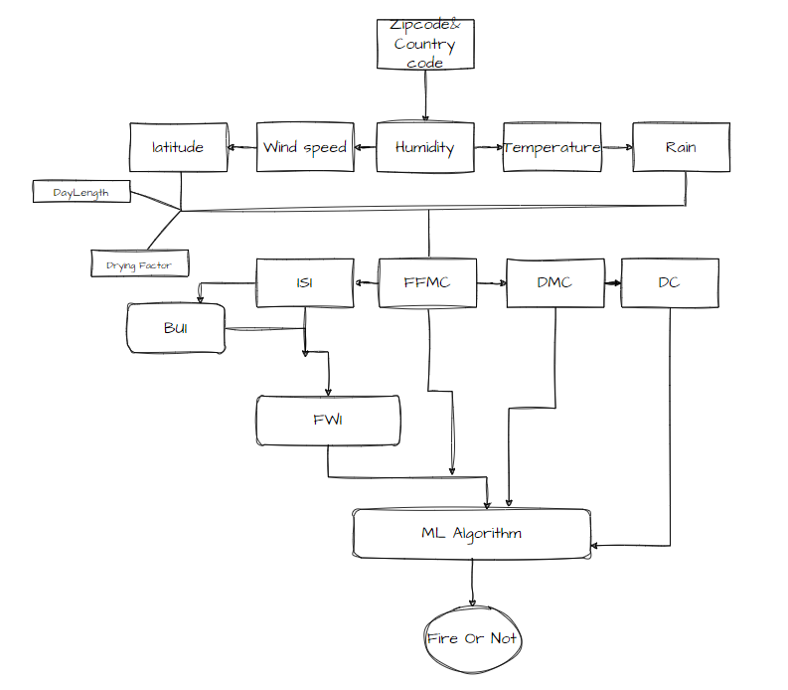

Steps Involved in Workflow:
1.Giving Inputs:
User will give the inputs like zip code and country code
2.Retrieving weather data:
By the help of open weather API, we created an API that will give the details like
Temperature, Latitude, Humidity and Windspeed. This is the input of next steps.

3.Calculating Daylength and Drying Factor:
Day length and Drying factor is calculated by using latitude and month.

4.Calculating FFMC:
Fine Fuel Moisture Code, describe the moisture content of fine fuel, such as leaves,
needles, and fine woody debris. The FFMC value is used to assess fire danger and
predict fire behaviour.

5.Calculating ISI:
Initial Spread Index". The Initial Spread Index (ISI) is a numerical rating system used
to predict the rate of fire spread in wildland fires. The ISI is based on a combination of environmental factors such as wind speed, relative humidity, and fuel moisture, which determine how easily a fire will spread and how intense it will become. The ISI is used in fire weather forecasting and fire management planning to help predict fire behaviour and make informed decisions about fire suppression efforts.

6.Calculating BUI:
It Assess the amount of fuel available for combustion in a given area. The BUI is calculated based on the moisture content of the fuels, and it provides a numerical representation of the fuel load in an area. The higher the BUI value, the greater the fuel load, and the greater the potential for fire spread, while a lower BUI value indicates a lower fuel load and a lower risk of fire spread.
7.Calculating DMC:
The Duff Moisture Code (DMC) is a numerical rating system used in forest management to describe the moisture content of forest duff, which is the layer of partially decomposed organic matter that covers the forest floor. The purpose of the DMC system is to provide a consistent and standardized method for estimating duff moisture, which is an important factor in predicting fire behaviour and assessing fire risk. Duff moisture is a key component of fire behaviour, as it affects the ease with which a fire can start and spread. The DMC system provides a way to quantify duff moisture content and provides a common language for fire managers to use in communicating about fire risk. The DMC system ranges from 0 (completely dry) to 100 (saturated), providing a clear and concise way to express the moisture level of the duff layer

8. Calculating Drought Code:
Provide a measure of the dryness of fuels in a given area and to assess the potential for fire spread representation of the current fire danger in an area the higher the DC value, the greater the risk of fire spread, and vice versa.
09.Calculating ISI:
Used to assess the potential for rapid fire spread. The ISI is calculated based on the wind speed and the fuel moisture content in an area, and it provides a numerical representation of the likelihood of fire spreading quickly from an ignition point. The higher the ISI value, the greater the potential for rapid fire spread, and vice versa.
10.Calculating FWI:
FWI and provide an overall assessment of the fire danger in a given area

11.Giving Inputs to the Machine Learning Model:
The random forest algorithm operates by splitting the training data into several subsets and building a decision tree for each subset. During the prediction phase, the input data is passed through each tree in the forest, and the predictions from each tree are combined to make the final prediction. This combination can be done by taking a majority vote for classification tasks or by taking the average of the predictions for regression tasks. It is an ensemble method that builds multiple decision trees and combines their predictions to arrive at a final prediction. Each decision tree in the forest is grown using a different subset of the training data, which helps to reduce overfitting and improve the model's generalization ability.
It will give the output to the user by you are in fire zone or not.

Conclusion:
Low humidity and High temperature will Impact the FWI (Forest weather index), It give more FWI value More FWI more Fire will likely to be happen. Ensemble learning method is used and bagging also included to reduce overfitting. By entering the zip code user will get the output as the zip coded area is in fire zone or not. It will be a boon for tourist on their summer vacation and it will be useful for forest officers. By using IMD dataset and sensors will improve the prediction accuracy.

for Fire fighters, Tourists, Guides

